***3.1. - Theoretical frame:***

***3.1.1. - Oscilloscope:*** An oscilloscope, CRO (for cathode-ray oscilloscope), or DSO (for the more modern digital storage oscilloscope), is a type of electronic test instrument that allows observation of constantly varying signal voltages, usually as a two-dimensional plot of one or more signals as a function of time. Other signals (such as sound or vibration) can be converted to voltages and displayed.

Oscilloscopes are used to observe the change of an electrical signal over time, such that voltage and time describe a shape which is continuously graphed against a calibrated scale. The observed waveform can be analyzed for such properties as amplitude, frequency, rise time, time interval, distortion and others. Modern digital instruments may calculate and display these properties directly.

Originally, calculation of these values required manually measuring the waveform against the scales built into the screen of the instrument. The oscilloscope can be adjusted so that repetitive signals can be observed as a continuous shape on the screen. A storage oscilloscope allows single events to be captured by the instrument and displayed for a relatively long time, allowing observation of events too fast to be directly perceptible.

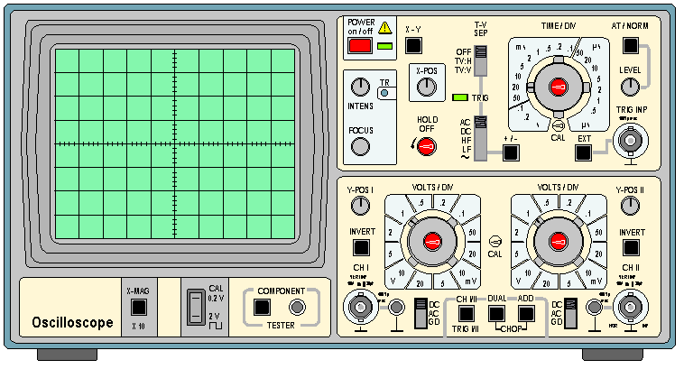

Figure 3.1 Hameg HM 203-6 oscilloscope

The basic oscilloscope is typically divided into four sections: the display, vertical controls, horizontal controls and trigger controls. The display is usually a CRT or LCD panel which is laid out with both horizontal and vertical reference lines referred to as the graticule. In addition to the screen, most display sections are equipped with three basic controls: a focus knob, an intensity knob and a beam finder button.

Many scopes have measurement tools, which help to quickly quantify frequency, amplitude, and other waveform characteristics. In general a scope can measure both time-based and voltage-based characteristics:

Timing characteristics:

* Frequency and period – Frequency is defined as the number of times per second a waveform repeats. And the period is the reciprocal of that (number of seconds each repeating waveform takes). The maximum frequency a scope can measure varies, but it’s often in the 100’s of MHz (1E6 Hz) range.
* Duty cycle – The percentage of a period that a wave is either positive or negative (there are both positive and negative duty cycles). The duty cycle is a ratio that tells you how long a signal is “on” versus how long it’s “off” each period.
* Rise and fall time – Signals can’t instantaneously go from 0V to 5V, they have to smoothly rise. The duration of a wave going from a low point to a high point is called the rise time, and fall time measures the opposite. These characteristics are important when considering how fast a circuit can respond to signals.

Voltage characteristics:

* Amplitude – Amplitude is a measure of the magnitude of a signal. There are a variety of amplitude measurements including peak-to-peak amplitude, which measures the absolute difference between a high and low voltage point of a signal. Peak amplitude, on the other hand, only measures how high or low a signal is past 0V.
* Maximum and minimum voltages – The scope can tell the user exactly how high and low the voltage of your signal gets.
* Mean and average voltages – Oscilloscopes can calculate the average or mean of the signal, and it can also tell you the average of the signal’s minimum and maximum voltage.

Display:

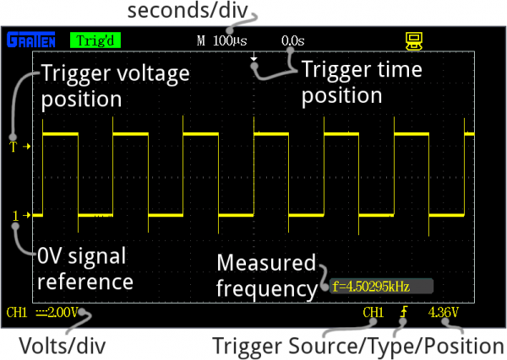

Figure 3.2 Display of a oscilloscope

Every oscilloscope display should be crisscrossed with horizontal and vertical lines called divisions. The scale of those divisions are modified with the horizontal and vertical systems. The vertical system is measured in “volts per division” and the horizontal is “seconds per division”. Generally, scopes will feature around 8-10 vertical (voltage) divisions, and 10-14 horizontal (seconds) divisions.

The vertical section of the scope controls the voltage scale on the display. There are traditionally two knobs in this section, which allow you to individually control the vertical position and volts/div.

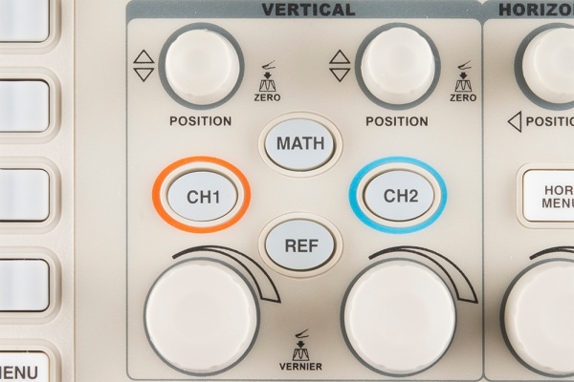

Figure 3.3 Oscilloscope´s vertical and horizontal controls.

The more critical volts per division knob allows you to set the vertical scale on the screen. Rotating the knob clockwise will decrease the scale, and counter-clockwise will increase. A smaller scale – fewer volts per division on the screen – means you’re more “zoomed in” to the waveform.

The position knob controls the vertical offset of the waveform on the screen. Rotate the knob clockwise, and the wave will move down, counter-clockwise will move it up the display. You can use the position knob to offset part of a waveform off the screen.

The horizontal section of the scope controls the time scale on the screen. Like the vertical system, the horizontal control gives you two knobs: position and seconds/div.

The position knob can move your waveform to the right or left of the display, adjusting the horizontal offset.

Trigger:

The trigger section is devoted to stabilizing and focusing the oscilloscope. The trigger tells the scope what parts of the signal to “trigger” on and start measuring. If your waveform is periodic, the trigger can be manipulated to keep the display static and unflinching.

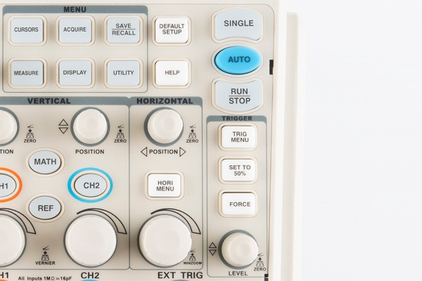

Figure 3.4 Trigger controls.

A series of buttons and screen menus make up the rest of the trigger system. Their main purpose is to select the trigger source and mode. There are a variety of trigger types, which manipulate how the trigger is activated:

* An edge trigger is the most basic form of the trigger. It will key the oscilloscope to start measuring when the signal voltage passes a certain level. An edge trigger can be set to catch on a rising or falling edge (or both).
* A pulse trigger tells the scope to key in on a specified “pulse” of voltage. You can specify the duration and direction of the pulse. For example, it can be a tiny blip of 0V -> 5V -> 0V, or it can be a seconds-long dip from 5V to 0V, back to 5V.
* A slope trigger can be set to trigger the scope on a positive or negative slope over a specified amount of time.

***3.1.2. – Function Generator:***

Function generators are items of test equipment that are able to generate a variety of simple repetitive waveforms. Straightforward signal generators such as RF signal generators or simple audio oscillators focus on producing a good sine waves, but in many cases other waveforms are needed. In addition to producing sine waves, function generators may typically produce other repetitive waveforms including saw tooth and triangular waveforms, square waves, and pulses. Another feature included on many function generators is the ability to add a DC offset. Often some of the low end function generators may only operate up to frequencies of possibly around 100 kHz as the various shaped waveforms are normally only needed at lower frequencies. However many other more comprehensive function generators are able to operate at much higher frequencies, often up to 10 or 20 MHz.

Capabilities of a Function Generator:

* Sine wave: A function generator will normally have the capability to produce a standard sine wave output. This is the standard waveform that oscillates between two levels with a standard sinusoidal shape.

Figure 3.5 sine wave

* Square wave: A square wave is normally relatively easy for a function generator to produce. It consists of a signal moving directly between high and low levels.

Figure 3.6 square wave

* Triangular wave: This form of signal produced by the function generator linearly moves between a high and low point.

Figure 3.7 triangular wave

* Saw tooth wave: This is a triangular waveform, but with the rise edge of the waveform faster or slower than the fall, making a form of shape similar to a saw tooth.

***Conclusion:***

The way we developed the practice was tiring due to the fact that we had to complete it in 1 day, but thanks to the investigation we made before finishing it, we knew how to use the function generator and oscilloscope and with that the rest of the practice was pretty easy, since all we had to do was calculate some values and see how the circuits we developed were evaluated in it.

The next time that we use an oscilloscope we will know how many tools it can offers us and how to exploit them.

***Bibliography:***

<http://www.circuitstoday.com/function-generators>

<http://www.facstaff.bucknell.edu/mastascu/elessonshtml/basic/basic5kv.html>

<http://ffden-2.phys.uaf.edu/211.fall2000.web.projects/Jeremie%20Smith/page3.htm>

<http://www.bkprecision.com/support/downloads/function-and-arbitrary-waveform-generator-guidebook.html>

<https://learn.sparkfun.com/tutorials/how-to-use-an-oscilloscope>

<https://www.youtube.com/watch?v=CzY2abWCVTY>

<http://www.tek.com/learning/oscilloscope-tutorial>